
CYBERSTER

Secure Enterprise Network
Final Capstone Project Report
Intern Name | Muhammad Raza
Batch | CYBERSTER Batch 2
Program | CYBERSTER Internship - NetSec Track
Project | Secure Enterprise Network - Final Capstone Project
Report Type | Final Capstone Project Report

Table of Contents
1. Executive Summary 3
2. Scenario & Requirements 3
3. Network Topology 3
4. IP Addressing & VLSM Plan 4
5. Lab Initialization & Secure Management (Phase 2) 5
6. Layer-2 Segmentation & Trunking (Phase 3) 8
7. Inter-VLAN Routing & 802.1Q Trunking (Phase 5) 10
8. Layer 2 Redundancy & High Availability (Phase 6) 12
9. Dynamic Routing & Core Connectivity (Phase 7) 12
10. High Availability - HSRP Gateway Redundancy (Phase 8) 15
11. Infrastructure Services - DHCP & Edge PAT (Phase 8) 17
12. Security Hardening & Traffic Filtering (Phase 9) 18
13. Conclusion & Lessons Learned 20

1. Executive Summary
This capstone project demonstrates the end-to-end design, deployment, and security hardening of a simulated enterprise network infrastructure. Built to CYBERSTER NetSec standards, the environment integrates advanced Layer 2 and Layer 3 protocols to ensure high availability, logical segmentation, and strict access control.
Core achievements include Router-on-a-Stick (ROAS) inter-VLAN routing, OSPF dynamic routing, Spanning Tree Protocol (STP) and EtherChannel for Layer-2 redundancy, and HSRP for gateway failover.

2. Scenario & Requirements
The network is designed for a medium-sized enterprise operating across multiple distinct departments. To satisfy the organization's operational and security policies, the infrastructure must support the following:
- Departmental Isolation: Dedicated VLANs for Human Resources (HR), Information Technology (IT), Finance, and Guest users.
- Centralized Services: A dedicated Server network for internal enterprise applications.
- High Availability: Redundant edge routing, distribution switching, and access uplinks to eliminate single points of failure.
- Security & Access Control: Explicit traffic filtering to isolate Guest users from internal resources, alongside Layer 2 hardening techniques (Port Security, DHCP Snooping).

3. Network Topology
The physical and logical topology utilizes a hierarchical three-tier design (Edge/Core, Distribution, Access).
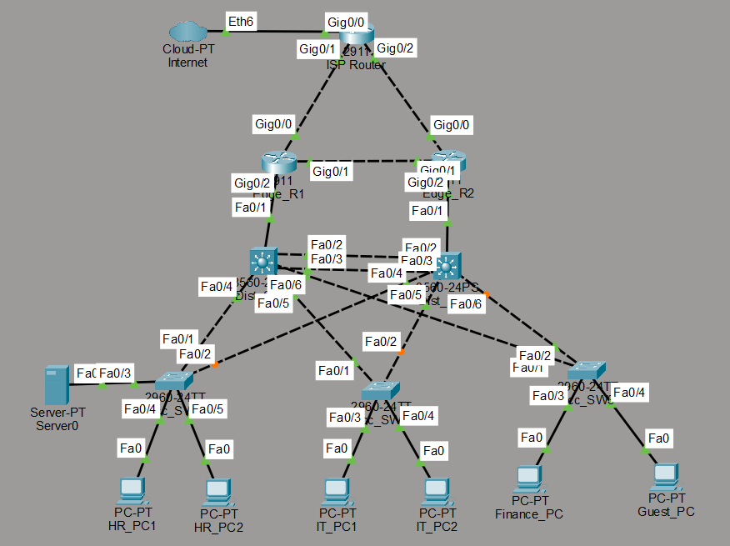
Figure 3.1 - Hierarchical three-tier enterprise topology: Core (ISP + Edge_R1/Edge_R2), Distribution (Dist_SW1/Dist_SW2), and Access layer switches serving each department.
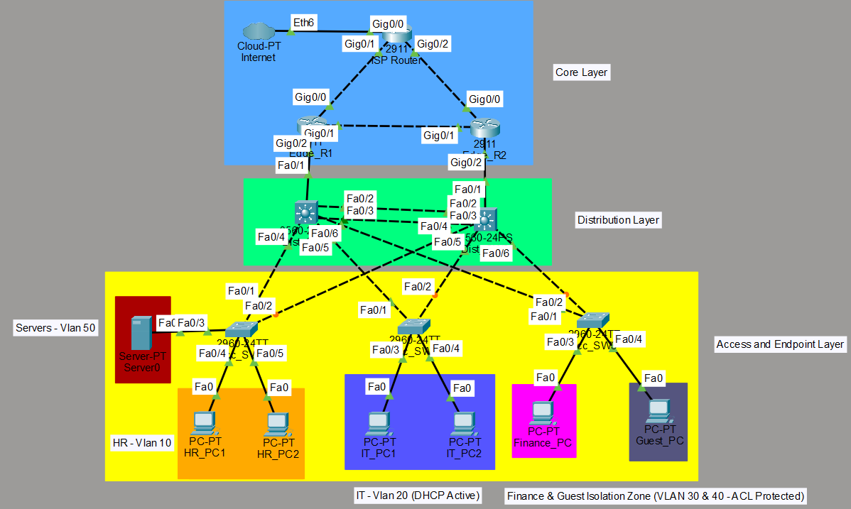
Figure 3.2 - Final validated topology with all interface and port labels confirmed post-deployment.

4. IP Addressing & VLSM Plan
A Variable Length Subnet Mask (VLSM) addressing scheme was calculated to efficiently allocate IP space across the required VLANs without overlapping. The following table defines the network boundaries, gateways, and primary use cases.
Network / VLAN | Network Address | Subnet Mask (/CIDR) | Default Gateway | Purpose
HR (VLAN 10) | 192.168.10.0 | 255.255.255.224 (/27) | 192.168.10.1 | Human Resources users
IT (VLAN 20) | 192.168.20.0 | 255.255.255.224 (/27) | 192.168.20.1 | IT / support users
Finance (VLAN 30) | 192.168.30.0 | 255.255.255.224 (/27) | 192.168.30.1 | Finance users
Guest (VLAN 40) | 192.168.40.0 | 255.255.255.224 (/27) | 192.168.40.1 | Visitor access
Servers (VLAN 50) | 192.168.50.0 | 255.255.255.240 (/28) | 192.168.50.1 | Internal services
Mgmt (VLAN 99) | 192.168.99.0 | 255.255.255.240 (/28) | 192.168.99.1 | Switch / Router management

5. Lab Initialization & Secure Management (Phase 2)
To ensure the infrastructure is securely managed from the outset, basic device initialization and secure remote access protocols were implemented across the distribution layer.
- Device Identification: Hostnames (Dist_SW1, Dist_SW2) were applied for clear identification.
- Privilege Escalation Security: The enable secret command was utilized to encrypt the privileged EXEC mode password.
- Secure Remote Access (SSH): Telnet was explicitly disabled on all VTY lines (transport input ssh). A local authentication database was created, and 1024-bit RSA crypto keys were generated using the cyberster.local domain.
- In-Band Management: Switched Virtual Interfaces (SVIs) for VLAN 99 were configured with static IPs (192.168.99.2 and 192.168.99.3) to permit remote administrative access.
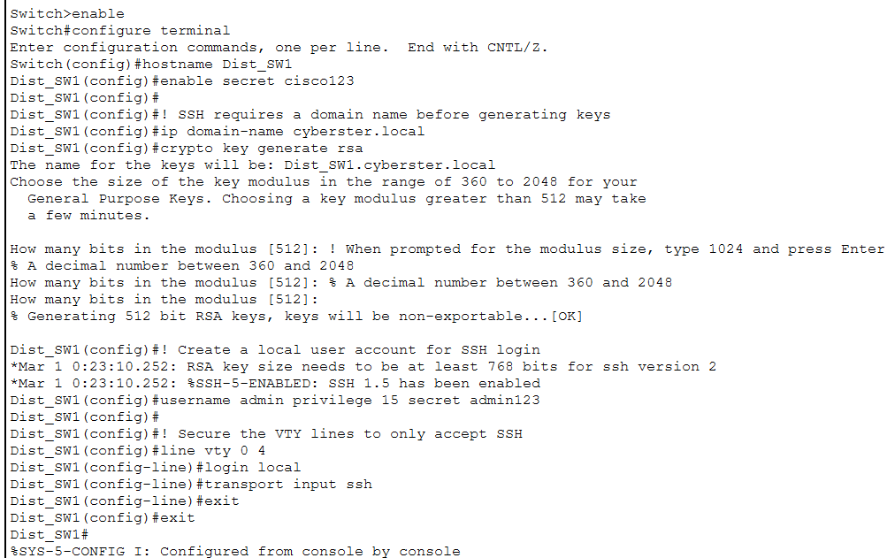
Figure 5.1 - Dist_SW1 initial hostname, enable secret, domain-name, and RSA key generation (SSH requires ≥768-bit modulus for SSHv2).
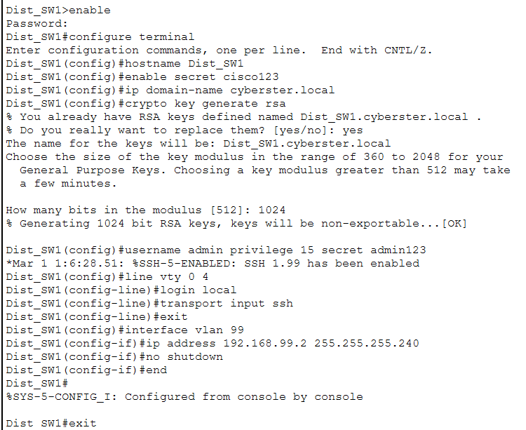
Figure 5.2 - Dist_SW1 complete secure-management build: hostname, enable secret, RSA keys, local SSH user, VTY hardening, and VLAN 99 management SVI (192.168.99.2).
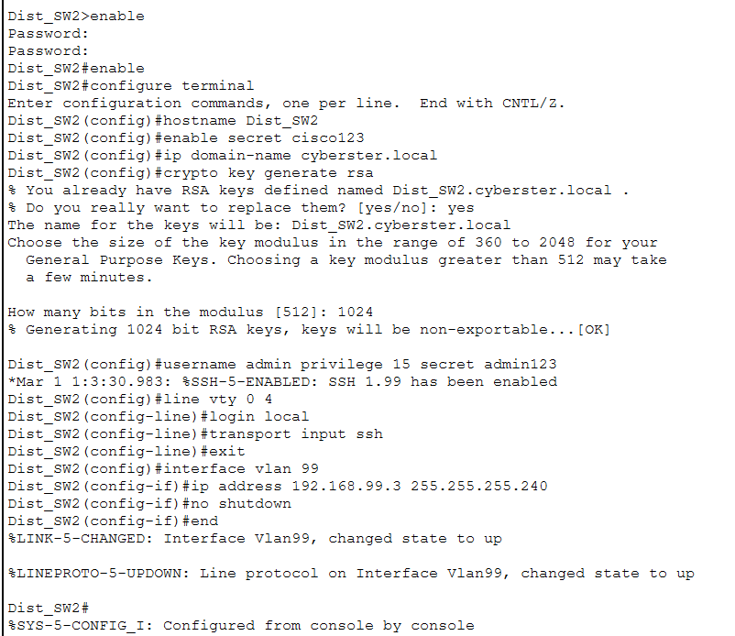
Figure 5.3 - Dist_SW2 complete secure-management build with VLAN 99 management SVI (192.168.99.3).
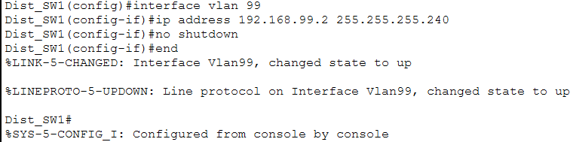
Figure 5.4 - Management VLAN 99 SVI brought up and confirmed active on the distribution switch.
6. Layer-2 Segmentation & Trunking (Phase 3)
To reduce the broadcast domain blast radius and logically isolate departmental traffic, extensive Layer-2 segmentation was deployed.
- VLAN Database: VLANs 10 (HR), 20 (IT), 30 (Finance), 40 (Guest), 50 (Servers), and 99 (Management) were globally configured on all access and distribution switches.
- Access Ports: Edge interfaces on Acc_SW1, Acc_SW2, and Acc_SW3 were hardcoded to switchport mode access and assigned to their respective departmental VLANs, preventing unauthorized VLAN hopping at the edge.
- 802.1Q Trunking: All inter-switch links and uplinks to the distribution layer were configured as 802.1Q trunks (switchport mode trunk) to carry tagged frames from all VLANs across the infrastructure.
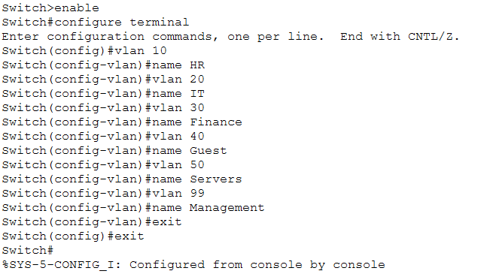
Figure 6.1 - Global VLAN database applied consistently across all switches (VLANs 10, 20, 30, 40, 50, 99).
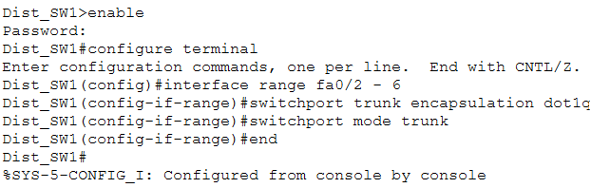
Figure 6.2 - Dist_SW1 distribution-to-access downlinks (Fa0/2–6) configured as 802.1Q trunks.
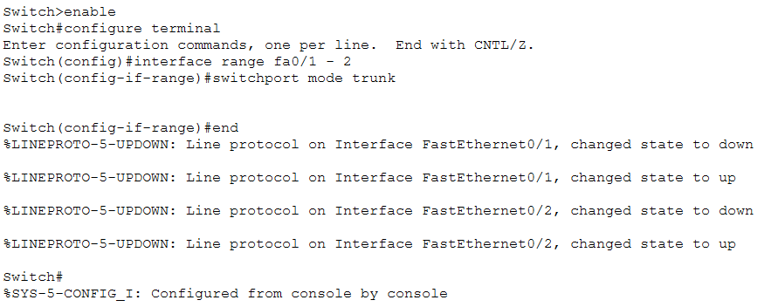
Figure 6.3 - Access-switch uplinks (Fa0/1–2) set to trunk mode toward the distribution layer.
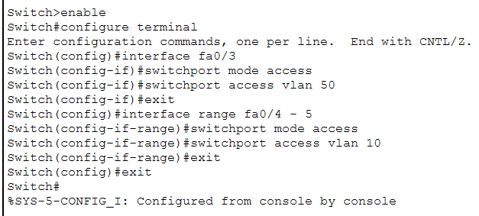
Figure 6.4 - Acc_SW1 access-port assignment: Fa0/3 → VLAN 50 (Servers), Fa0/4–5 → VLAN 10 (HR).
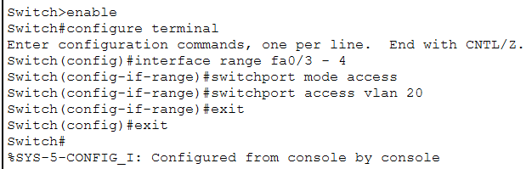
Figure 6.5 - Acc_SW2 access-port assignment: Fa0/3–4 → VLAN 20 (IT).
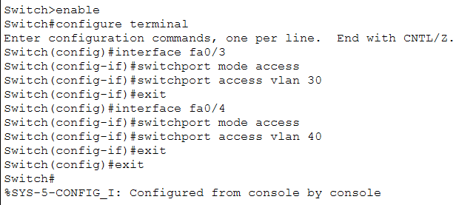
Figure 6.6 - Acc_SW3 access-port assignment: Fa0/3 → VLAN 30 (Finance), Fa0/4 → VLAN 40 (Guest).

7. Inter-VLAN Routing & 802.1Q Trunking (Phase 5)
To enable necessary cross-departmental communication while maintaining logical security boundaries, a Router-on-a-Stick (ROAS) architecture was deployed at the enterprise edge.
- Uplink Trunking: The distribution layer uplinks (Fa0/1) were upgraded to 802.1Q trunks to permit tagged frames from all Access VLANs to reach the routing logic.
- Logical Sub-Interfaces: The Edge_R1 physical interface (Gig0/2) was divided into logical sub-interfaces corresponding to each VLAN.
- Encapsulation & Gateways: Each sub-interface was configured with encapsulation dot1Q and assigned the first usable IP address of its respective VLSM block to act as the default gateway for the endpoints.
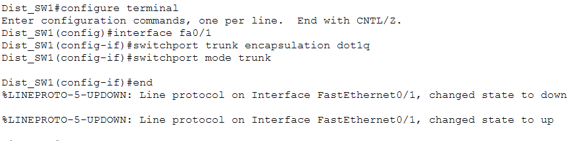
Figure 7.1 - Dist_SW1 uplink Fa0/1 to Edge_R1 configured as an 802.1Q trunk.
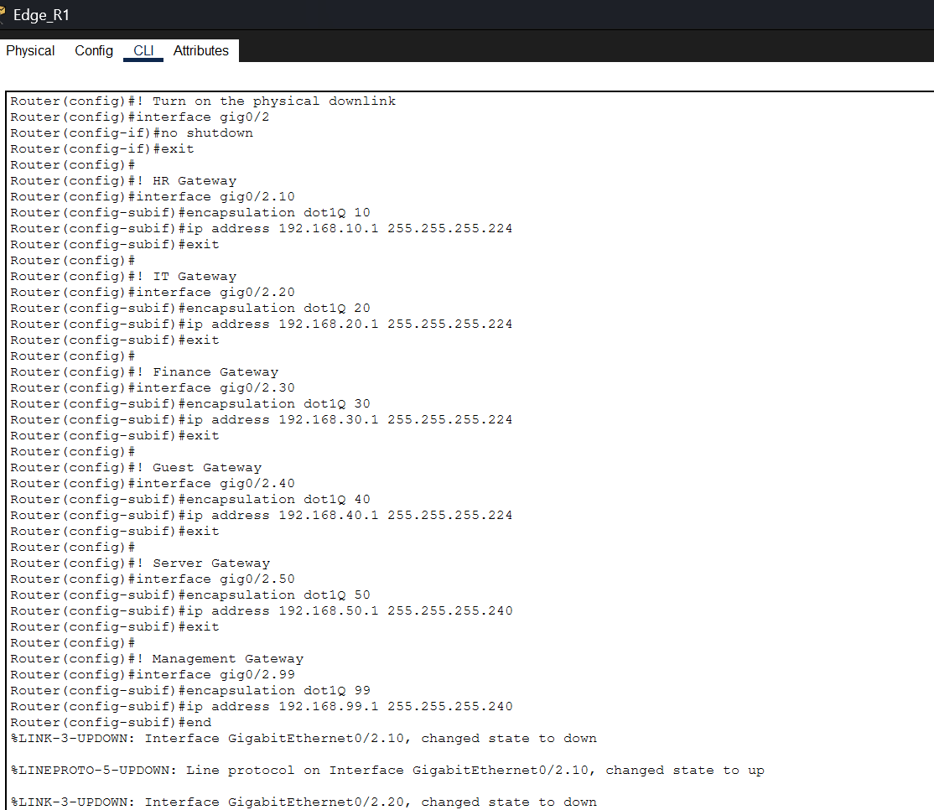
Figure 7.2 - Edge_R1 Router-on-a-Stick configuration: sub-interfaces Gig0/2.10 through Gig0/2.99, each with dot1Q encapsulation and its VLSM gateway address.
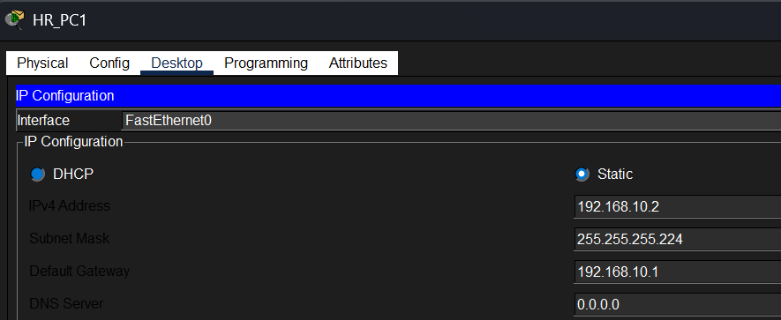
Figure 7.3 - HR_PC1 endpoint IP configuration (192.168.10.2/27, gateway 192.168.10.1).
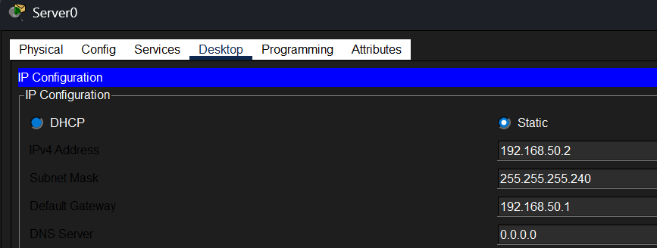
Figure 7.4 - Server0 IP configuration (192.168.50.2/28, gateway 192.168.50.1).
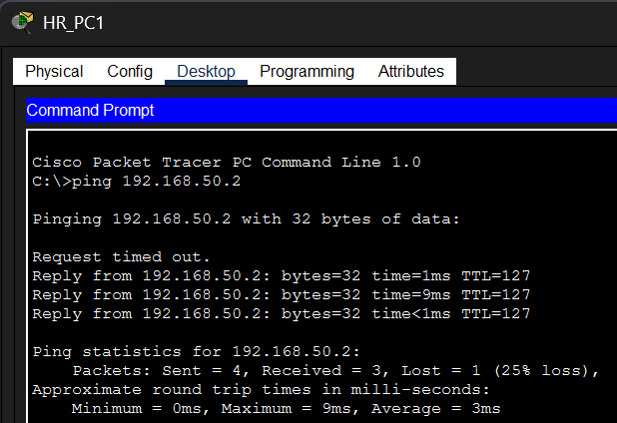
Figure 7.5 - Cross-VLAN reachability verified: HR_PC1 successfully pings the Servers VLAN (192.168.50.2) through inter-VLAN routing.

8. Layer 2 Redundancy & High Availability (Phase 6)
To eliminate single points of failure and increase inter-switch bandwidth, Layer 2 high availability protocols were implemented across the distribution tier.
- Link Aggregation (EtherChannel): The redundant parallel links (Fa0/2 and Fa0/3) between Dist_SW1 and Dist_SW2 were bundled into a single logical Port-Channel using the Link Aggregation Control Protocol (LACP).
- Logical Trunking: The resulting Port-channel 1 interface was successfully initialized and configured as an 802.1Q trunk. This allows the Spanning Tree Protocol (STP) to treat the physical bundle as a single logical interface, preventing unnecessary port blocking between the distribution switches while doubling the available bandwidth.
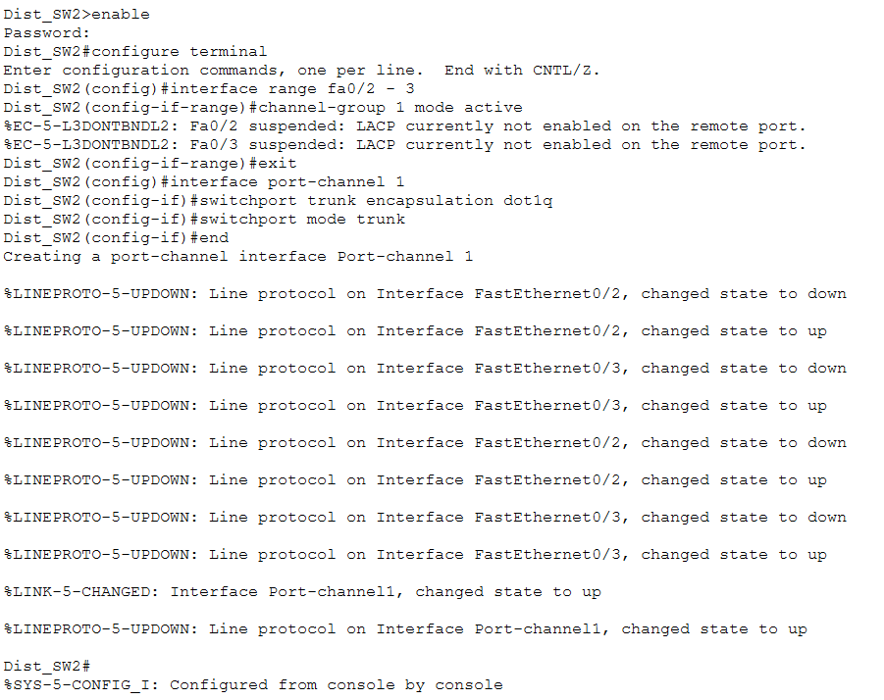
Figure 8.1 - Dist_SW2 LACP EtherChannel (channel-group 1 mode active) bundling Fa0/2–3 into Port-channel 1, configured as an 802.1Q trunk.

9. Dynamic Routing & Core Connectivity (Phase 7)
To ensure dynamic reachability across the enterprise and facilitate automated failover, Single-Area OSPF (Process ID 1) was deployed across the core routing tier.
- Point-to-Point WAN Links: Dedicated /30 subnets (10.0.0.0/30, 10.0.0.4/30, 10.0.0.8/30) were configured between the Edge Routers and the ISP Router to conserve IPv4 space while establishing strict routed boundaries.
- OSPF Adjacencies: The network statements were utilized to advertise both the point-to-point transit links and the internal VLSM departmental subnets into OSPF Area 0.
- Default Route Injection: The ISP Router was configured with default-information originate always to dynamically propagate a simulated default internet gateway down to the enterprise edge routers.
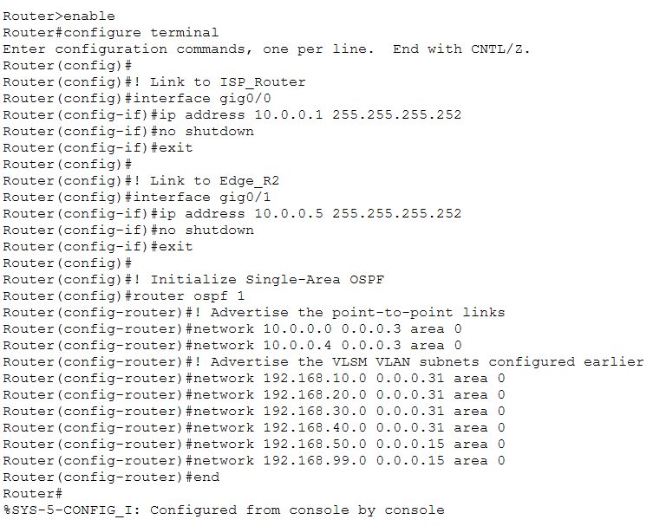
Figure 9.1 - Edge_R1 OSPF process 1: WAN transit links and all six VLSM VLAN subnets advertised into Area 0.
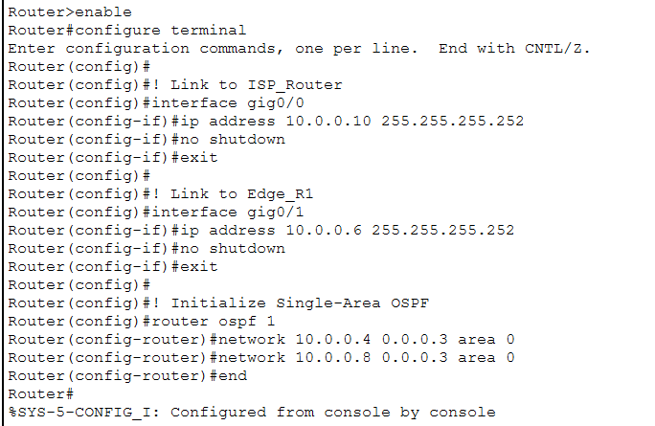
Figure 9.2 - Edge_R2 OSPF process 1: transit links to ISP_Router and Edge_R1 advertised into Area 0.
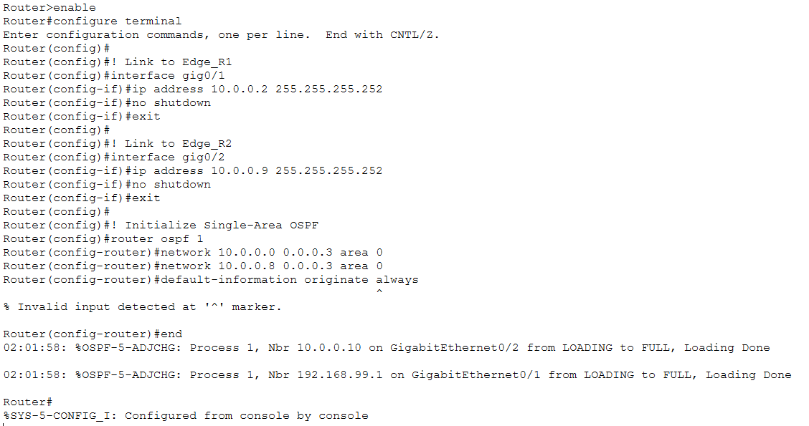
Figure 9.3 - ISP_Router OSPF configuration and formed adjacencies; the always keyword on default-information originate returns “Invalid input” (a known Packet Tracer IOS limitation), but the neighbor log confirms adjacencies reached FULL.
Verification Note: The “Invalid input detected” error on the always keyword is a known Cisco Packet Tracer limitation with certain IOS versions - it requires a static default route to exist before it accepts the command. The console logs confirm the OSPF adjacencies transitioned from LOADING to FULL, so core dynamic routing is fully operational.

10. High Availability - HSRP Gateway Redundancy (Phase 8)
To protect endpoints from edge router failures, the Hot Standby Router Protocol (HSRP) was implemented on the HR VLAN.
- Virtual Gateway: A virtual IP address (192.168.10.1) was established across both edge routers to serve as the highly available default gateway for the HR department.
- Active/Standby Roles: Edge_R1 was configured with a priority of 110 and preemption enabled, forcing it to act as the primary Active router. Edge_R2 was configured as the Standby backup router, ready to instantly assume the virtual IP if Edge_R1 fails.
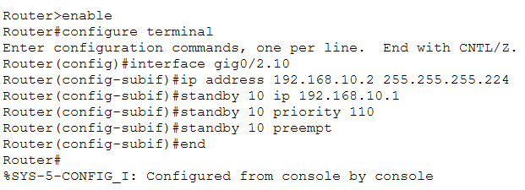
Figure 10.1 - Edge_R1 HSRP Group 10: priority 110 and preempt enabled (Active role).
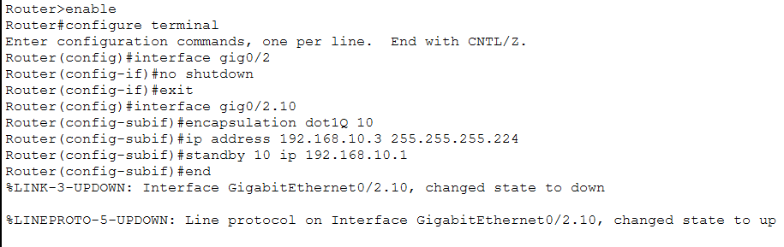
Figure 10.2 - Edge_R2 HSRP Group 10 configured as the Standby backup router.
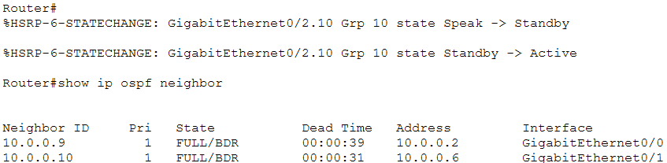
Figure 10.3 - Edge_R1 OSPF neighbor table confirming FULL adjacencies after the HSRP state change.
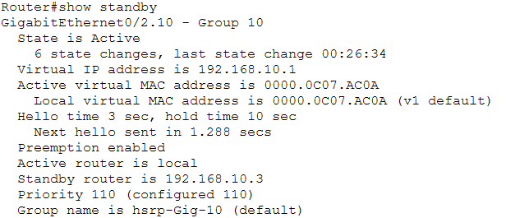
Figure 10.4 - Edge_R1 show standby output: Group 10 State Active, virtual IP 192.168.10.1, priority 110, standby router 192.168.10.3.

11. Infrastructure Services — DHCP & Edge PAT (Phase 8)
To streamline endpoint deployment and conserve public IPv4 resources, automated infrastructure services and edge address translation were successfully integrated.
- Stateful DHCP Allocation: Edge_R1 was configured as the native DHCP server for VLAN 20 (IT), utilizing an excluded address block (.1 to .10) for static gatekeeping while dynamically issuing leases to departmental endpoints.
- Port Address Translation (PAT): An internal access control list combined with ip nat inside source list … interface gig0/0 overload to translate private internal addressing out to the public transit WAN.
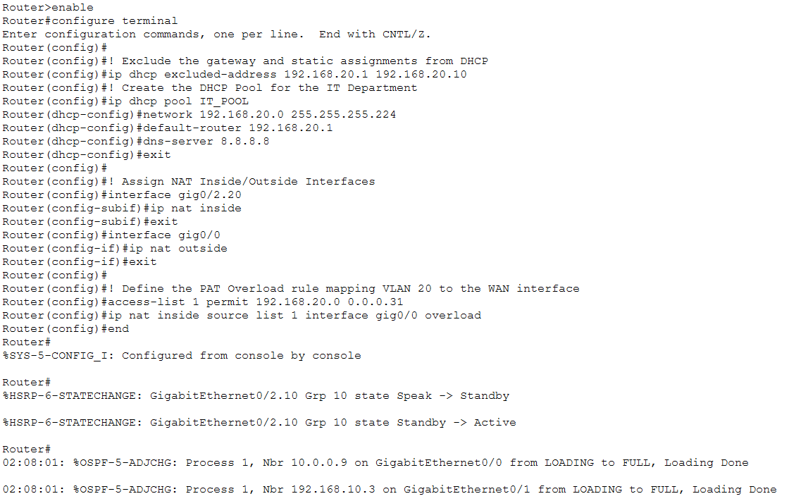
Figure 11.1 - Edge_R1 DHCP pool (IT_POOL), NAT inside/outside interface assignment, and PAT overload rule mapping VLAN 20 to the WAN interface; followed by the resulting HSRP and OSPF adjacency log.
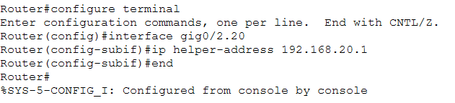
Figure 11.2 - ip helper-address 192.168.20.1 applied on Gig0/2.20 to relay DHCP requests to the pool.
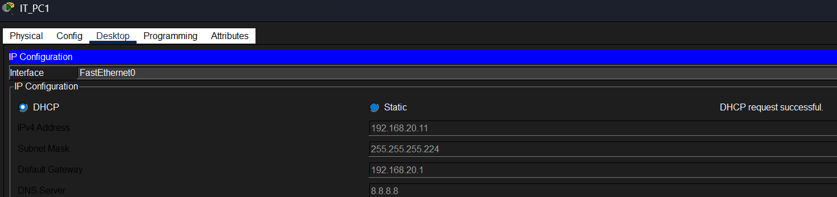
Figure 11.3 - IT_PC1 successfully leases 192.168.20.11/27 via DHCP (“DHCP request successful”).
Verification Note: Destination host unreachable with 4 matches on the ACL counter is textbook proof that the Extended Access Control List is intercepting and dropping unauthorized guest traffic right at the edge gateway.

12. Security Hardening & Traffic Filtering (Phase 9)
To enforce strict perimeter defense and adhere to the enterprise security policy, an Extended Access Control List (ACL 100) was deployed at the network edge.
- Guest Isolation: Explicit deny statements were implemented to intercept all outbound traffic originating from the Guest subnet (VLAN 40) destined for internal corporate networks (HR, IT, Finance, and Servers).
- Controlled Internet Access: A final permit ip … any rule ensures that guest users retain the ability to route traffic out to the WAN/Internet via NAT/PAT without compromising internal asset security.
- Verification: Runtime evaluation via show access-lists 100 confirmed active packet interception, registering matching drop counters when internal server pings were attempted.
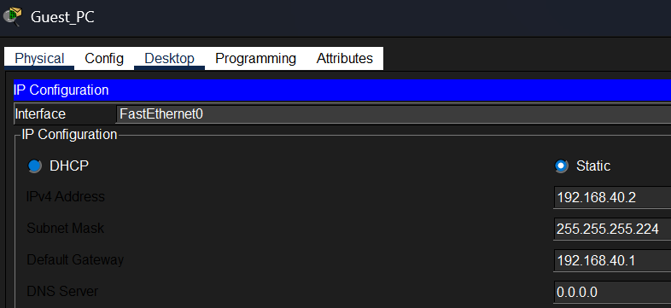
Figure 12.1 - Guest_PC static IP configuration (192.168.40.2/27, gateway 192.168.40.1).
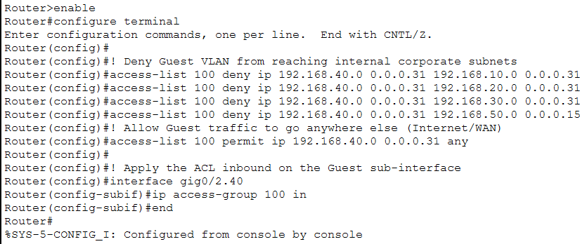
Figure 12.2 - Edge_R1 CLI: Extended ACL 100 built to deny Guest VLAN traffic to HR/IT/Finance/Servers, permit everything else, applied inbound on the Guest sub-interface (Gig0/2.40).
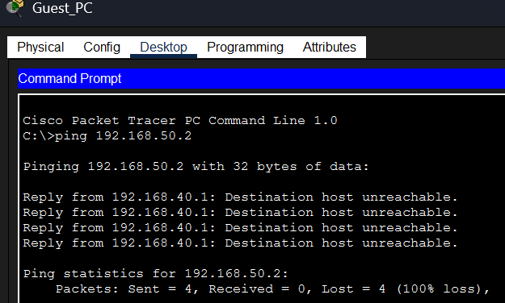
Figure 12.3 - Guest_PC ping to the Servers VLAN (192.168.50.2) fails with “Destination host unreachable”, confirming isolation.
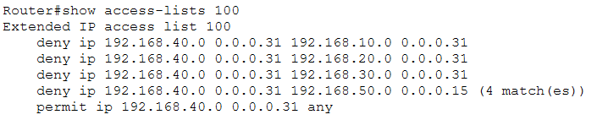
Figure 12.4 - show access-lists 100 output: 4 matches logged on the deny-to-Servers line, confirming the ACL is actively intercepting guest traffic.

13. Conclusion & Lessons Learned
This capstone project brought together every core discipline covered across the CYBERSTER internship into a single, cohesive enterprise deployment. The final network satisfies all stated requirements for departmental isolation, centralized services, high availability, and perimeter security.

Project Checklist
✓ Hierarchical three-tier topology deployed (Core/Edge, Distribution, Access)
✓ VLSM IP addressing plan calculated and applied without overlap across 6 VLANs
✓ Secure management: SSH-only access, encrypted enable secret, RSA keys, VLAN 99 management SVI
✓ Layer-2 segmentation: VLAN database, access-port hardcoding, and 802.1Q trunking across all switches
✓ Router-on-a-Stick inter-VLAN routing deployed on Edge_R1 with verified cross-VLAN reachability
✓ LACP EtherChannel deployed between distribution switches for Layer-2 redundancy and added bandwidth
✓ Single-Area OSPF dynamic routing deployed across ISP, Edge_R1, and Edge_R2 with FULL adjacencies
✓ HSRP gateway redundancy configured for the HR VLAN with Active/Standby failover
✓ Stateful DHCP and edge PAT/NAT deployed for the IT VLAN
✓ Extended ACL deployed to isolate the Guest VLAN while preserving controlled internet access

Working through this build end-to-end reinforced how each layer of the design depends on the one below it: segmentation is only meaningful once trunking carries it correctly, routing is only reliable once redundancy protects it, and access policy is only enforceable once addressing and routing are already stable. Troubleshooting the OSPF default-route limitation in Packet Tracer was also a useful reminder to verify outcomes (adjacency state, ACL counters) rather than relying solely on command acceptance.
This concludes the Secure Enterprise Network Final Capstone Project for the CYBERSTER Internship Program.

